CTM-I Test Plan

Welcome

Version 0.1

Screen: Welcome

Use Case Name | Welcome
User Roles | Firm User (CTMI_Firm_Options_Admin, CTMI_Firm_Options_Admin, CTMI_Firm_Options_Clerk, CTMI_Firm_Options_Broker), Market Ops (CTMI_Help_Desk), Ops (CTMI_Systems), App Support (CTMI_Root)
Pre-conditions /Assumptions | User has successfully logged into the CTM-I application and Welcome Page is displaying
Post Conditions | None
Screenshot | 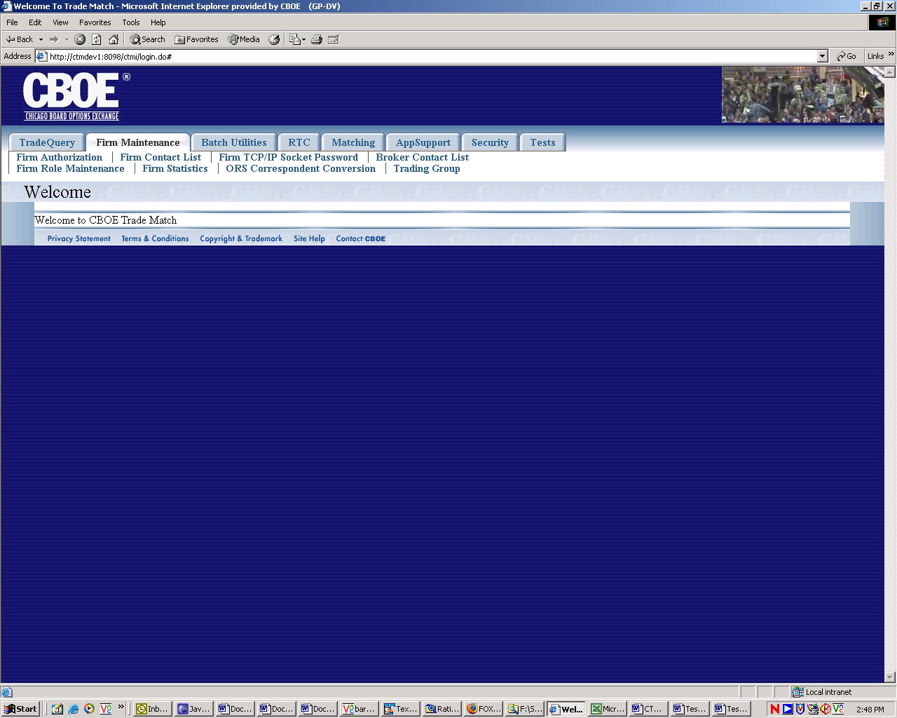
Test Scenario A | User Role : CTMI_Firm_Options_Root, User Id: xxx Password: xxx
 | Action | Expected Out Come |  | Comments/Results
Test Case 1  Successful Logon | User successfully Logs In with given User Id and Password | User Sees the Welcome Page with the following Menu tabs.  - Trade Query  - Firm Maintenance  - Security
 | User Puts the mouse pointer on each of the menu tabs. | The following sub-menus appear underneath when mouse pointer is hovered on each of the menu tabs.  - Trade Query  - Trade Query  - Trade Message  - Trade Entry  - Firm Maintenance  - Firm Authorization  - Firm Contact List  - TCP-IP Socket Password  - Broker Contact List  - Firm Role Maintenance  - Firm Statistics  - ORS Correspondence Conversion  - Trading Group  - Security  a. User Maintenance
Test Scenario B | Repeat above test cases with login with diff user roles namely Ops (CTMI_Firm_Options_Admin)  User Id: xxx Password: xxx
 | User successfully Logs In with given User Id and Password | User Sees the Welcome Page with the following Menu tabs.  - Trade Query  - Firm Maintenance  - Security
 | User Puts the mouse pointer on each of the menu tabs. | The following sub-menus appear underneath when mouse pointer is hovered on each of the menu tabs.  - Trade Query  - Trade Message  - Firm Maintenance  - Firm Authorization  - Firm Contact List  - Broker Contact List  - Firm Role Maintenance  - Firm Statistics  - ORS Correspondence Conversion  - Trading Group  - Security  - User Maintenance
Test Scenario C | Repeat above test cases with login with diff user roles namely Ops (CTMI_Firm_Options_Clerk)  User Id: xxx Password: xxx
 | User successfully Logs In with given User Id and Password | User Sees the Welcome Page with the following Menu tabs.  - Trade Query  - Firm Maintenance
 | User Puts the mouse pointer on each of the menu tabs. | The following sub-menus appear underneath when mouse pointer is hovered on each of the menu tabs.  - Trade Query  - Trade Query  - Trade Message  - Firm Maintenance  - Firm Contact List  - Broker Contact List  - Firm Statistics
Test Scenario D | Repeat above test cases with login with diff user roles namely Ops (CTMI_Firm_Options_Broker) User Id: xxx Password: xxx
Test Scenario E | Repeat above test cases with login with diff user roles namely AppSupport (CTMI_Root)  User Id: xxx Password: xxx
 | User successfully Logs In with given User Id and Password | User Sees the Welcome Page with the following Menu tabs.  - Trade Query  - Firm Maintenance  - Batch Utilities  - RTC  - Matching  - App Support  - Security  - Tests
 | User Puts the mouse pointer on each of the menu tabs. | The following sub-menus appear underneath when mouse pointer is hovered on each of the menu tabs.  - Trade Query  - Trade Query  - Trade Message  - Futures Trade Query  - Trade Entry  - Firm Maintenance  - Firm Authorization  - Firm Contact List  - TCP-IP Socket Password  - Broker Contact List  - Firm Role Maintenance  - Firm Statistics  - ORS Correspondence Conversion  - Trading Group  - Batch Utilities  - Wire Authorization  - Batch Load  - Batch Delete  - RTC  - Drop Copy  - TCP/IP Resend  - Matching  - Status Display  - Tier Match  - Control Update  - Batch Match  - App Support  - Parm Browse  - Log Control  - Audit Query  - Internal Switch Maintenance  - Backdoor Futures Delete  - Backdoor FUO  - Field Security Maintenance  - Range Delete  - Role Maintenance  - Security  - User Maintenance  - Tests  - Field Authorization Test
Test Scenario F | Repeat above test cases with login with diff user roles namely AppSupport (CTMI_Systems)  User Id: xxx Password: xxx
 | User successfully Logs In with given User Id and Password | User Sees the Welcome Page with the following Menu tabs.  - Trade Query  - Firm Maintenance  - Batch Utilities  - RTC  - Matching  - App Support
 | User Puts the mouse pointer on each of the menu tabs. | The following sub-menus appear underneath when mouse pointer is hovered on each of the menu tabs.  - Trade Query  - Trade Query  - Trade Message  - Futures Trade Query  - Firm Maintenance  - Firm Authorization  - Firm Contact List  - TCP-IP Socket Password  - Broker Contact List  - Firm Role Maintenance  - Firm Statistics  - Trading Group  - Batch Utilities  - RTC  - Drop Copy  - Matching  - Status Display  - Tier Match  - Control Update  - Batch Match  - App Support  - Log Control  - Audit Query  - Internal Switch Maintenance  - Security
Test Scenario G | Repeat above test cases with login with diff user roles namely AppSupport (CTMI_Help_Desk)  User Id: xxx Password: xxx
 | User successfully Logs In with given User Id and Password | User Sees the Welcome Page with the following Menu tabs.  - Trade Query  - Firm Maintenance  - Batch Utilities  - RTC  - Matching  - App Support  - Security  - Tests
 | User Puts the mouse pointer on each of the menu tabs. | The following sub-menus appear underneath when mouse pointer is hovered on each of the menu tabs.  - Trade Query  - Trade Query  - Trade Message  - Futures Trade Query  - Trade Entry  - Firm Maintenance  - Firm Authorization  - Firm Contact List  - Broker Contact List  - Firm Statistics  - ORS Correspondence Conversion  - Trading Group  - Batch Utilities  - Wire Authorization  - Batch Load  - RTC  - Drop Copy  - TCP/IP Resend  - Matching  - Status Display  - Tier Match  - Control Update  - Batch Match  - App Support  - Audit Query  - Range Delete  - Security  - User Maintenance

Test Scenario H

